

**Department of Computer Science and Engineering**

XCS508

Software Engineering Laboratory

**MINI PROJECT REPORT**

**ON**

# MOBILE RECHARGE PORTAL SYSTEM

Submitted by:

NATARAJ. C –121012012756

B.Tech – CSE ( III Year )

**Table of Contents**

1.Aim

2. Software Specification Requirements

3.UML Diagrams

4. Project Management Plan

5. Implementation

6.Output

7. Testing Phase

8. Conclusion

9. References

**Aim :**

The aim of mobile recharge portal system is to redefine convenience in the digital era. With a commitment to seamless transactions, user-friendly interfaces, and a comprehensive range of recharge options, Our aim is to provide convenient and efficient mobile recharge solutions, enhancing connectivity for users while prioritizing reliability, simplicity, and customer satisfaction.we strive to empower users with secure, and personalized mobile recharge experience, enhancing connectivity for all.

**Software Requirements Specification (SRS) for Mobile Recharge Portal System**

**1. Introduction :**

**1.1 Purpose**

The purpose of this document is to outline the requirements for the development of a Mobile Recharge Portal System, aiming to streamline and enhance the user experience in mobile recharge transactions.

**1.2 Scope**

The scope includes the design, development, testing, and deployment of a web-based portal system that facilitates mobile recharge for various service providers.

**1.3 Definitions, Acronyms, and Abbreviations**

MRPS – Mobile Recharge Portal System

GUI – Graphical User Interface

**2. System Overview:**

**2.1 System Description**

The Mobile Recharge Portal System is designed to provide users with a user-friendly platform for seamless mobile recharge transactions. It supports multiple service providers and ensures secure, efficient transactions.

**2.2 Key Features**

2.2.1 User Registration and Authentication

2.2.2 Recharge Options for Multiple Service Providers

2.2.3 Secure Payment Gateway Integration

2.2.4 Transaction History and Receipts

2.2.5 User Account Management

**3. Functional Requirements:**

3.1 User Registration and Authentication

3.1.1 Users must be able to register with valid credentials.

3.1.2 Secure authentication mechanisms must be implemented.

**3.2 Recharge Process**

3.2.1 Users should be able to select their service provider.

3.2.2 Users must input mobile number and recharge amount.

3.2.3 Real-time validation of mobile numbers and recharge amounts.

**3.3 Payment Processing**

3.3.1 Integration with a secure payment gateway.

3.3.2 Support for multiple payment methods (credit cards, wallets, etc.).

**3.4 Transaction History**

3.4.1 Users should be able to view a history of their recharge transactions.

3.4.2 Downloadable receipts for each transaction.

**4. Non-Functional Requirements:**

**4.1 Performance**

4.1.1 System response time should be within 3 seconds.

4.1.2 Support concurrent transactions without performance degradation.

**4.2 Security**

4.2.1 Implement HTTPS for secure data transmission.

4.2.2 Encrypt sensitive user information.

**4.3 User Interface**

4.3.1 Intuitive and responsive design.

4.3.2 Support for various devices and screen sizes.

**5. Constraints:**

**5.1 Compatibility**

5.1.1 Compatibility with major web browsers (Chrome, Firefox, Safari).

**5.2 Regulatory Compliance**

5.2.1 Adherence to local regulations and standards.

**6. Future Enhancements:**

**6.1 Mobile App Integration**

6.1.1 Explore the possibility of developing a mobile app for enhanced accessibility.

.

**7. Conclusion:**

This Software Requirements Specification provides a comprehensive overview of the Mobile Recharge Portal System, defining the necessary functionalities and constraints for successful implementation. This document will serve as a guide for the development team, ensuring a successful and user-centric system.

**UML DIAGRAMS :**

USECASE DIAGRAM FOR MOBILE RECHARGE PORTAL SYSTEM

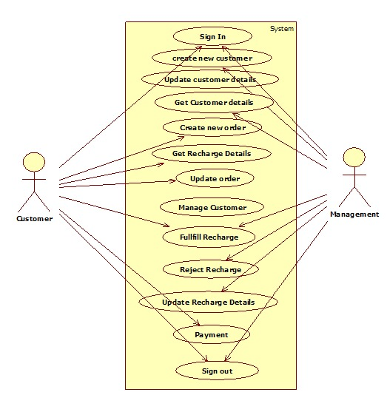

CLASS DIAGRAM FOR MOBILE RECHARGE PORTAL SYSTEM

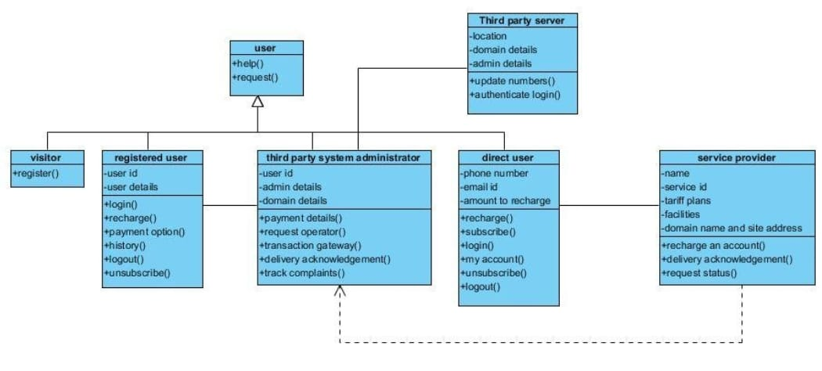

SEQUENCE DIAGRAM FOR MOBILE RECHARGE PORTAL SYSTEM

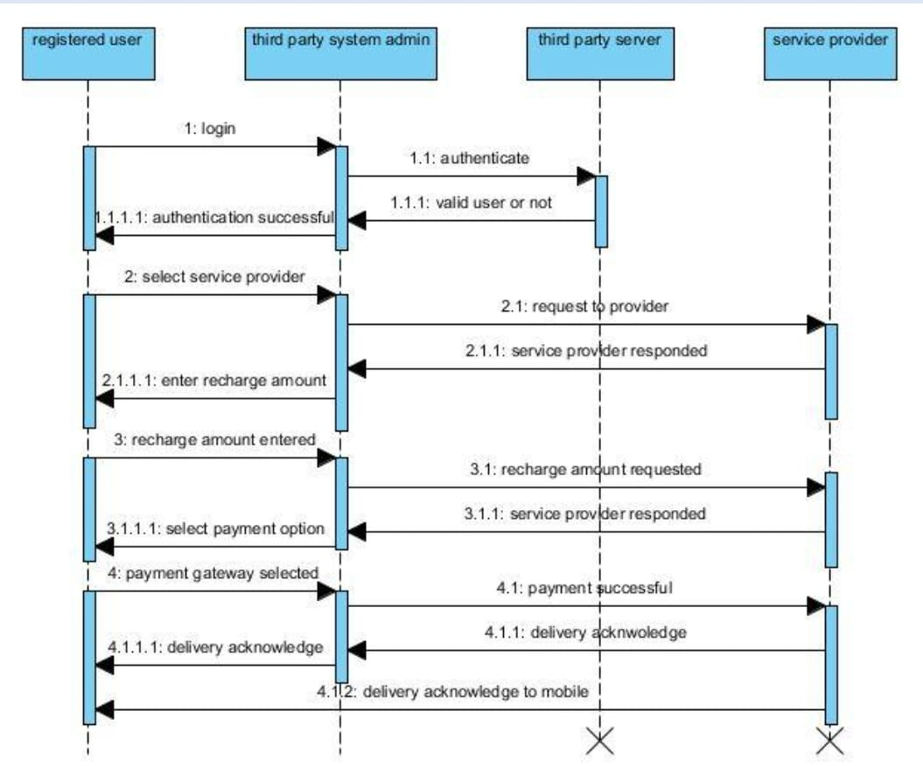

ACTIVITY DIAGRAM FOR MOBILE RECHARGE PORTAL SYSTEM

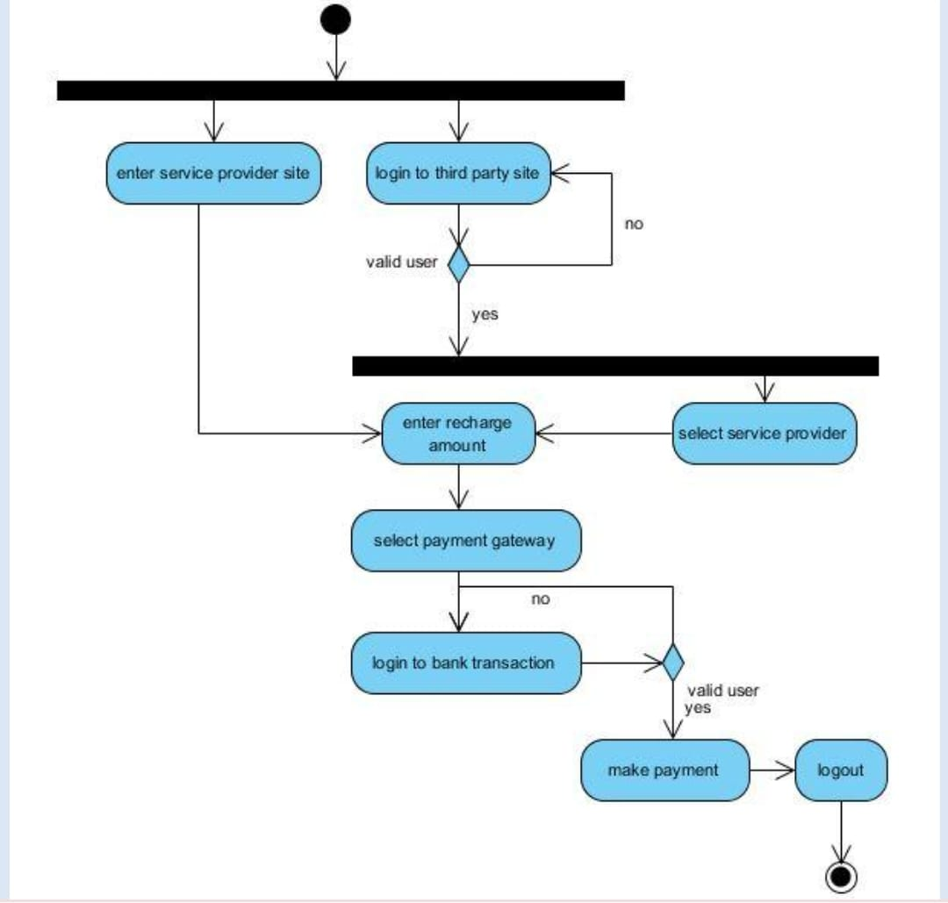

DEPLOYMENT DIAGRAM FOR MOBILE RECHARGE PORTAL SYSTEM

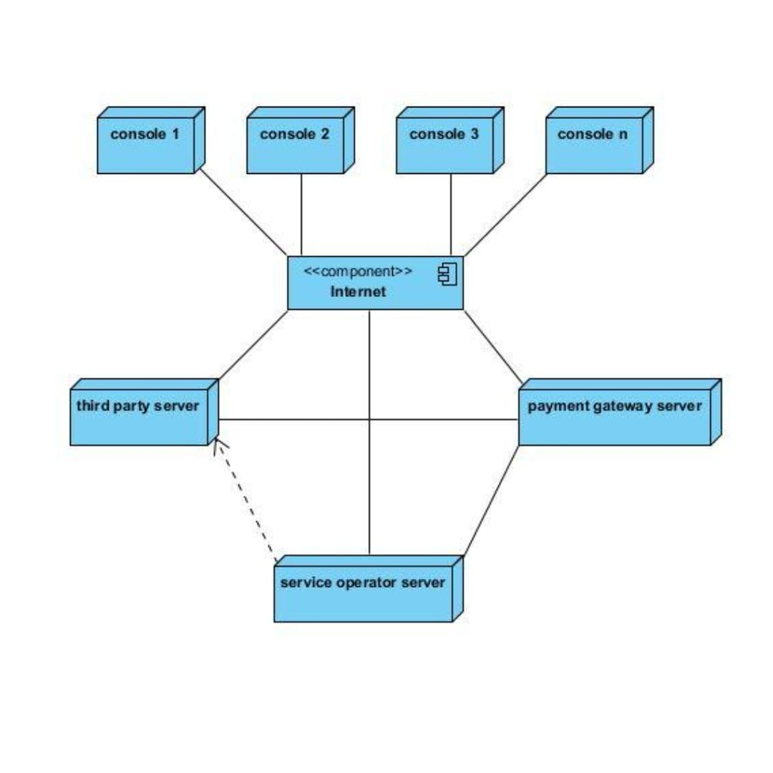

STATECHART DIAGRAM FOR MOBILE RECHARGE PORTAL SYSTEM

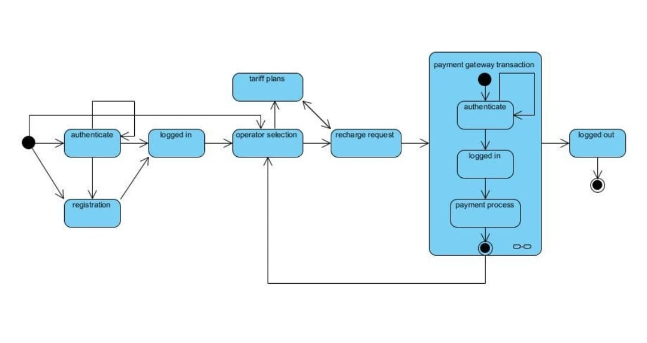

COLLABORATION DIAGRAM FOR MOBILE RECHARGE PORTAL SYSTEM

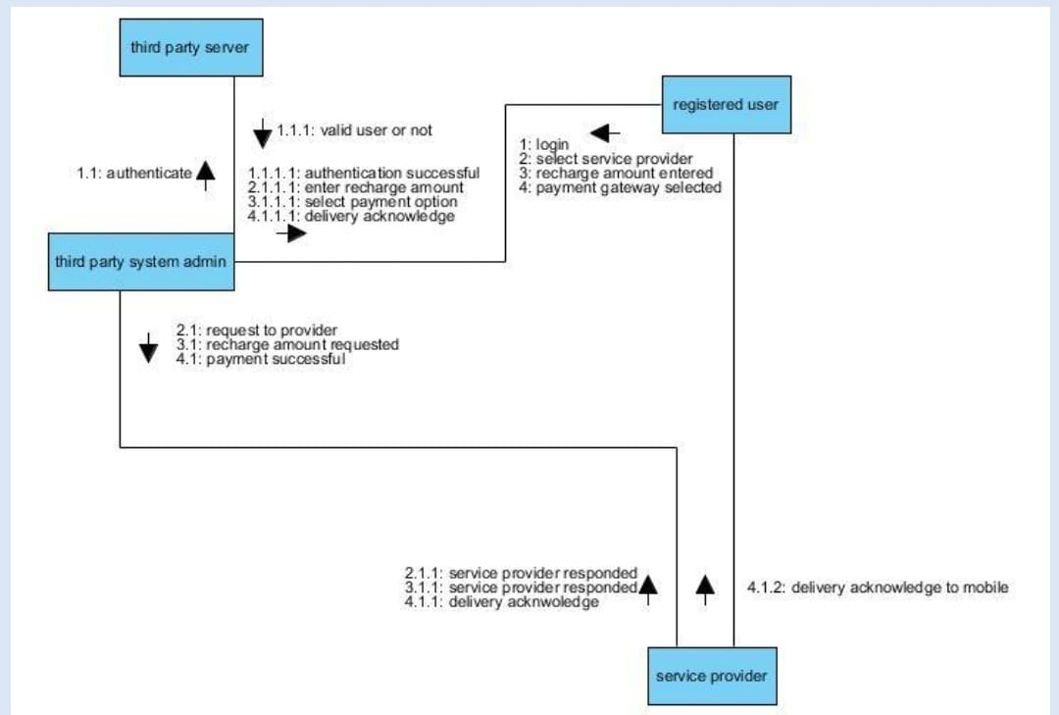

**Project Management Plan :**

A Project Management Plan (PMP) outlines the approach, processes, and resources that will be used to develop and deliver a project successfully. Below is a high-level template for a Project Management Plan for Mobile Recharge Portal System .

**Project Management Plan for Mobile Recharge Portal System** .

**1. Executive Summary**

1.1 Project Overview

The Mobile Recharge Portal System project is initiated to address the growing demand for a streamlined and user-friendly platform for mobile recharge transactions. As mobile connectivity plays a crucial role in today's digital era, the system aims to provide an efficient and secure solution for users to recharge their mobile phones across various service providers.

1.2 Project Manager

The project manager is responsible for coordinating the efforts of the project team, managing resources, and ensuring that the project meets its objectives within the specified constraints.

2. Project Objectives

The primary objective of this project is to develop a web-based portal that facilitates seamless mobile recharge experiences. The system will support multiple service providers, offering a diverse range of recharge options while ensuring secure payment processing. The goal is to enhance user connectivity through a user-centric and technologically advanced platform

3. Project Scope

The project scope includes the design, development, testing, and deployment of the Mobile Recharge Portal System. It encompasses user registration, recharge options for various service providers, secure payment processing, transaction history tracking, and user account management.

4. Project Team

4.1 Roles and Responsibilities

Project Manager: NATARAJ C

Lead Developer: NATARAJ C

Quality Assurance Specialist: Santhosh M

5. Project Timeline

Milestones:

Project Initiation and Planning: [26/11/23]

System Design and Architecture: [27/11/23]

Development: [27/11/23] - [29/11/23]

Testing and Quality Assurance: [29/11/23]

Deployment: [30/11/23]

6. Risk Management

6.1 Identified Risks

Technical challenges in integrating with existing systems.

Changes in project scope from stakeholders.

6.2 Risk Assessment

Evaluate the impact and likelihood of each identified risk.

6.3 Risk Mitigation

Develop strategies for mitigating and managing identified risks

Potential data privacy and security risks.

6.2 Risk Mitigation Strategies

Conduct thorough system integration testing.

Implement a change control process for scope changes.

Adhere to data protection regulations and employ encryption protocols.

7. Communication Plan

7.1 Stakeholder Communication

Regular updates will be provided to stakeholders through weekly progress reports and monthly status meetings.

7.2 Team Communication

The project team will utilize communication tools for daily stand-ups and collaborative discussions.

8. Quality Management

8.1 Testing Procedures

Comprehensive testing will be conducted throughout the development lifecycle, including unit testing, integration testing, and user acceptance testing.

8.2 Acceptance Criteria

The mobile recharge portal system must meet predefined acceptance criteria for functionality, performance, security, and user experienc

**6.IMPLEMENTATION:**

SOURCE CODE FOR MOBILE RECHARGE PORTAL SYSTEM

<!DOCTYPE html>

<!-- html -->

<html>

<!-- head -->

<head>

<title>MOBILE RECHARGE PORTAL </title>

</head>

<header>

    <div class="container">

           <div class="logo">

                <h1><a href="index.html">Mobile Recharge Portal</a></h1>

            </div>

          <div class="login">

          <a data-toggle="modal" data-target="#myModal" href="#"><i class="glyphicon </i>Login/Register</a>

            </div>

                <div class="clearfix"></div>

        <div class="modal fade" id="myModal" tabindex="-1" role="dialog"

            aria-hidden="true">

            <div class="modal-dialog modal-lg">

                <div class="modal-content">

                    <div class="modal-header">

                        <button type="button" class="close" data-dismiss="modal" aria-hidden="true">

                            &times;</button>

                        <h4 class="modal-title" id="myModalLabel">

                            Online Recharge</h4>

                    </div>

                    <div class="modal-body">

                        <div class="row">

                                <!-- Nav tabs -->

                                <ul class="nav nav-tabs">

                                    <li class="active"><a href="#Login" data-tggle="tab">Login</a></li>

                                    <li><a href="#Registration" data-toggle="tab">Register</a></li>

                                </ul>

                                <!-- Tab panes -->

                                <div class="tab-content">

                                    <div class="tab-pane active" id="Login">

                                        <form  class="form-horizontal" action="#" method="get">

                                        <div class="form-group">

                                            <label for="email" class="col-sm-2 control-label">

                                                Email</label>

                                            <div class="col-sm-10">

                                                <input type="email" class="form-control" id="email1" placeholder="Email" required="required" />

                                            </div>

                                        </div>

                                        <div class="form-group">

                                            <label for="exampleInputPassword1" class="col-sm-2 control-label">

                                                Password</label>

                                            <div class="col-sm-10">

                                                <input type="password" class="form-control" id="exampleInputPassword1" placeholder="password" required="required" />

                                            </div>

                                        </div>

                                        <div class="row">

                                            <div class="col-sm-2">

                                            </div>

                                            <div class="col-sm-10">

                                                <button type="submit" class="submit btn btn-primary btn-sm">

                                                    Submit</button>

                                                <a href="javascript:;" class="agileits-forgot">Forgot your password?</a>

                                            </div>

                                        </div>

                                        </form>

                                    </div>

                                    <div class="tab-pane" id="Registration">

                                        <form  class="form-horizontal" action="#" method="get">

                                        <div class="form-group">

                                            <label for="email" class="col-sm-2 control-label">

                                                Name</label>

                                            <div class="col-sm-10">

                                                <div class="row">

                                                    <div class="col-md-3 col-sm-3 col-xs-3">

                                                        <select class="form-control">

                                                            <option>Mr.</option>

                                                            <option>Ms.</option>

                                                            <option>Mrs.</option>

                                                        </select>

                                                    </div>

                                                    <div class="col-md-9 col-sm-9 col-xs-9">

                                                        <input type="text" class="form-control" placeholder="Name" required="required" />

                                                    </div>

                                                </div>

                                            </div>

                                        </div>

                                        <div class="form-group">

                                            <label for="email" class="col-sm-2 control-label">

                                                Email</label>

                                            <div class="col-sm-10">

                                                <input type="email" class="form-control" id="email" placeholder="Email" required="required" />

                                            </div>

                                        </div>

                                        <div class="form-group">

                                            <label for="mobile" class="col-sm-2 control-label">

                                                Mobile</label>

                                            <div class="col-sm-10">

                                                <input type="tel" class="form-control" id="mobile" placeholder="Mobile" required="required" />

                                            </div>

                                        </div>

                                        <div class="form-group">

                                            <label for="password" class="col-sm-2 control-label">

                                                Password</label>

                                            <div class="col-sm-10">

                                                <input type="password" class="form-control" id="password" placeholder="Password" required="required" />

                                            </div>

                                        </div>

                                        <div class="row">

                                            <div class="col-sm-2">

                                            </div>

                                            <div class="col-sm-10">

                                                <button type="submit" class="submit btn btn-primary btn-sm">

                                                    Save & Continue</button>

                                                <button type="reset" class="submit btn btn-default btn-sm">

                                                    Cancel</button>

                                            </div>

                                        </div>

                                        </form>

                                    </div>

<!--//-->

    <div class=" header-right">

        <div class="banner">

             <div class="slider">

                <div class="callbacks_container">

                  <ul class="rslides" id="slider">

                     <li>

                         <div class="banner1">

                            <div class="caption">

                                <h3><span>Get a</span> coupon voucher on Mobile Recharge</h3>

                                <p><a href="#mobilew3layouts" class="scroll">Recharge now</a></p>

                            </div>

                        </div>

                     </li>

                  </ul>

              </div>

            </div>

        </div>

    </div>

    <!--Vertical Tab-->

    <div class="categories-section main-grid-border" id="mobilew3layouts">

        <div class="container">

            <div class="category-list">

                <div id="parentVerticalTab">

                    <div class="agileits-tab_nav">

                    <ul class="resp-tabs-list hor_1">

                        <li><i class="icon fa fa-mobile" aria-hidden="true"></i>Mobile</li>

                    </ul>

                    </div>

                    <div class="resp-tabs-container hor_1">

                        <!-- tab1 -->

                        <div>

                            <div class="tabs-box">

                    <img src="images/mobile.png" class="w3ls-mobile" alt="" data-pin-nopin="true">

                <ul class="tabs-menu">

                    <li><a href="#tab1"><label class="radio"><input type="radio" name="radio" checked=""><i></i>Prepaid</label></a></li>

                    <li><a href="#tab2"><label class="radio"><input type="radio" name="radio"><i></i>Postpaid</label></a></li>

                </ul>

                 <div class="clearfix"> </div>

                 <div class="tab-grids">

                    <div id="tab1" class="tab-grid">

                              <div class="login-form">

                        <form action="pay.html" method="post" id="signup">

                        <ol>

                            <li>

                                <h4>Enter your mobile number</h4>

                                <input type="tel" id="tel" name="tel" pattern="\d{10}" placeholder="Enter Mobile Number" required="required" />

                                <p class="validation01">

                                    <span class="invalid">Please enter a valid mobile number</span>

                                    <span class="valid">That's what we wanted!</span>

                                </p>

                            </li>

                            <li>

                                <div class="agileits-select">

                                <select class="selectpicker show-tick" data-live-search="true" required="required" >

                                  <option data-tokens="Select Operator">Select Operator</option>

                                  <option data-tokens="Airtel">Airtel</option>

                                  <option data-tokens="BSNL">BSNL</option>

                                  <option data-tokens="Jio">Jio</option>

                                  <option data-tokens="Vodafone">Vodafone</option>

                                  <option data-tokens="Idea">VI</option>

                                </select>

                                </div>

                            </li>

                            <li>

                                <div class="agileits-select">

                                <select class="selectpicker show-tick" data-live-search="true" required="required" >

                                  <option data-tokens="Select Circle">Select Circle</option>

                                  <option data-tokens="Chennai">Chennai</option>

                                  <option data-tokens="Thanjavur">Thanjavur </option>

                                  <option data-tokens="Trichy">Trichy</option>

                                  <option data-tokens="Thiruvarur">Thiruvarur</option>

                                  <option data-tokens="">Nagapattinam</option>

                                </select>

                                </div>

                            </li>

                            <li>

                                <div class="mobile-right ">

                                    <h4>How Much To Recharge?</h4>

                                    <div class="mobile-rchge">

                                        <input type="text" placeholder="Enter amount" name="amount" required="required"  />

                                    </div>

                                    <div class="mobile-rchge">

                                        <a href="plans.html">VIEW ALL PLANS</a>

                                    </div>

                                    <div class="clearfix"></div>

                                </div>

                            </li>

                            <li>

                                <input type="submit" class="submit" value="Recharge Now" />

                            </li>

                        </ol>

                        </form>

                        </div>

                    </div>

                    <div id="tab2" class="tab-grid">

                              <div class="login-form">

                        <form action="file:///C:/Users/Mr.NATARAJ/Desktop/Online-Recharge-System-in-html%20(1)/Online-Recharge-System-in-html/pay.html" method="post" id="signup">

                        <ol>

                            <li>

                                <h4>Enter your mobile number</h4>

                                <input type="tel" id="tel" name="tel" pattern="\d{10}" placeholder="Enter Mobile Number" required />

                                <p class="validation01">

                                    <span class="invalid">Please enter a valid mobile number</span>

                                    <span class="valid">That's what we wanted!</span>

                                </p>

                            </li>

                            <li>

                                <div class="agileits-select">

                                <select class="selectpicker show-tick" data-live-search="true">

                                </div>

                            </li>

                                  <option data-tokens="Select Circle">Select Circle</option>

                                  <option data-tokens="Chennai">Chennai</option>

                                  <option data-tokens="Thanjavur">Thanjavur </option>

                                  <option data-tokens="Trichy">Trichy</option>

                                  <option data-tokens="Thiruvarur">Thiruvarur</option>

                                  <option data-tokens="">Nagapattinam</option>

                            <li>

                                <div class="agileits-select">

                                    <div class="mobile-right ">

                                    <h4>How Much To Pay?</h4>

                                    <div class="mobile-rchge">

                                        <input type="text" placeholder="Enter amount" name="amount" required="required"  />

                                    </div>

                                    <div class="clearfix"></div>

                                </div>

                            </li>

                            <li>

                                <input type="submit" class="submit" value="Pay bill" />

                            </li>

                        </ol>

                        </form>

                        </div>

                    </div>

                </div>

            <div class="clearfix"> </div>

        </div>

    <!-- script -->

        <script>

            $(document).ready(function() {

                $("#tab2").hide();

                $("#tab3").hide();

                $("#tab4").hide();

                $(".tabs-menu a").click(function(event){

                    event.preventDefault();

                    var tab=$(this).attr("href");

                    $(".tab-grid").not(tab).css("display","none");

                    $(tab).fadeIn("slow");

                });

                         </div>

                        <!-- /tab1 -->

            <!-- tab2 -->

                        <div>

                              <div class="login-form">

                                  <i class="icon fa fa-television inner-icon" aria-hidden="true"></i>

                        <form action="pay.html" method="post" id="signup">

                           <input type="text" id="customer" value="Enter Customer ID" onfocus="this.value = '';" onblur="if (this.value == '') {this.value = 'Enter Customer ID';}" required="">

                            </li>

                            <li>

                                <div class="mobile-right ">

                                    <div class="mobile-rchge">

                                        <input type="text" placeholder="Enter amount" name="amount" required="required"  />

                                    </div>

                                    <div class="clearfix"></div>

                                </div>

                            </li>

                            <li>

                                <input type="submit" class="submit" value="Recharge Now" />

                            </li>

                        </ol>

                        </form>

                        </div>

                        </div>

                        <!-- /tab2 -->

                        <!-- tab3 -->

                <div>

                    <i class="icon fa fa-credit-card inner-icon" aria-hidden="true"></i>

                    <div id="tab2" class="tab-grid">

                              <div class="login-form">

                        <form action="pay.html" method="post" id="signup">

    <!--Plug-in Initialisation-->

    <script type="text/javascript">

    $(document).ready(function() {

        //Vertical Tab

        $('#parentVerticalTab').easyResponsiveTabs({

            type: 'vertical', //Types: default, vertical, accordion

            width: 'auto', //auto or any width like 600px

            fit: true, // 100% fit in a container

            closed: 'accordion', // Start closed if in accordion view

            tabidentify: 'hor_1', // The tab groups identifier

            activate: function(event) { // Callback function if tab is switched

                var $tab = $(this);

                var $info = $('#nested-tabInfo2');

                var $name = $('span', $info);

                $name.text($tab.text());

                $info.show();

            }

        });

    });

</script>

    <!-- //Categories -->

<!-- Support content -->

    <div class="w3l-support">

        <div class="container">

            <div class="col-md-5 w3_agile_support_left">

                <img src="images/cus.jpg" alt=" " class="img-responsive" />

            </div>

            <div class="col-md-7 w3_agile_support_right">

                <h5>Mobile Recharge Portal</h5>

                <h2>Customer Service Support</h2>

                <p>Our 24/7 customer support for the mobile recharge portal includes phone, email, and live chat assistance.

                Our trained team ensures prompt, multilingual support, maintaining a comprehensive knowledge base.

                We prioritize user security, employ automated responses, and welcome feedback for continuous improvement,

                ensuring uninterrupted service and customer satisfaction</p>

                <div class="agile_more">

                    <a href="support.html" class="type-4">

                        <span> Support </span>

                        <span> Support  </span>

                        <span> Support  </span>

                        <span> Support  </span>

                        <span> Support  </span>

                        <span> Support  </span>

                    </a>

                </div>

            </div>

            <div class="clearfix"> </div>

        </div>

    </div>

<!-- //Support content -->

<!--footer-->

<footer>

    <div class="container-fluid">

        <div class="w3-agile-footer-top-at">

            <div class="col-md-2 agileits-amet-sed">

                <h4>Company</h4>

                <ul class="w3ls-nav-bottom">

                    <li><a href="support.html">Support</a></li>

                    <li><a href="feedback.html">Feedback</a></li>

                </ul>

            </div>

            <div class="col-md-3 agileits-amet-sed ">

                <h4>Mobile Recharges</h4>

                    <ul class="w3ls-nav-bottom">

                        <li><a href="#mobilew3layouts" class="scroll">Airtel</a></li>

                        <li><a href="#mobilew3layouts" class="scroll">Vi</a></li>

                        <li><a href="#mobilew3layouts" class="scroll">BSNL</a></li>

                        <li><a href="#mobilew3layouts" class="scroll">Jio</a></li>

                    </ul>

            </div>

            <div class="col-md-2 agileits-amet-sed ">

                <h4>Payment Options</h4>

                   <ul class="w3ls-nav-bottom">

                        <li>Credit Cards</li>

                        <li>Debit Cards</li>

                        <li>Paypal </li>

                    </ul>

            </div>

        <div class="clearfix"> </div>

        </div>

    </div>

    <div class="w3l-footer-bottom">

        <div class="container-fluid">

            <div class="col-md-4 w3-footer-logo">

                <h2><a href="index.html">MOBILE RECHARGE PORTAL</a></h2>

            </div>

        <div class="clearfix"> </div>

        </div>

    </div>

</footer>

<!--//footer-->

<!-- for bootstrap working -->

        <script src="js/bootstrap.js"></script>

<!-- //for bootstrap working --><!-- Responsive-slider -->

    <!-- Banner-slider -->

<script src="js/responsiveslides.min.js"></script>

   <script>

    $(function () {

      $("#slider").responsiveSlides({

        auto: true,

        speed: 500,

        namespace: "callbacks",

        pager: true,

      });

    });

  </script>

    <!-- //Banner-slider -->

<!-- //Responsive-slider -->

<!-- Bootstrap select option script -->

<script src="js/bootstrap-select.js"></script>

<script>

  $(document).ready(function () {

    var mySelect = $('#first-disabled2');

    $('#special').on('click', function () {

      mySelect.find('option:selected').prop('disabled', true);

      mySelect.selectpicker('refresh');

    });

    $('#special2').on('click', function () {

      mySelect.find('option:disabled').prop('disabled', false);

      mySelect.selectpicker('refresh');

    });

    $('#basic2').selectpicker({

      liveSearch: true,

      maxOptions: 1

    });

  });

</script>

<!-- //Bootstrap select option script -->

<!-- easy-responsive-tabs -->

<link rel="stylesheet" type="text/css" href="css/easy-responsive-tabs.css " />

<script src="js/easyResponsiveTabs.js"></script>

<!-- //easy-responsive-tabs -->

    <!-- here stars scrolling icon -->

            <script type="text/javascript">

                $(document).ready(function() {

                    /*

                        var defaults = {

                        containerID: 'toTop', // fading element id

                        containerHoverID: 'toTopHover', // fading element hover id

                        scrollSpeed: 1200,

                        easingType: 'linear'

                        };

                    */

                    $().UItoTop({ easingType: 'easeOutQuart' });

                    });

            </script>

            <!-- start-smoth-scrolling -->

            <script type="text/javascript" src="js/move-top.js"></script>

            <script type="text/javascript" src="js/easing.js"></script>

            <script type="text/javascript">

                jQuery(document).ready(function($) {

                    $(".scroll").click(function(event){

                        event.preventDefault();

                        $('html,body').animate({scrollTop:$(this.hash).offset().top},1000);

                    });

                });

            </script>

            <!-- start-smoth-scrolling -->

        <!-- //here ends scrolling icon -->

</body>

<!-- //body -->

</html>

<!-- //html -->

**Output :**

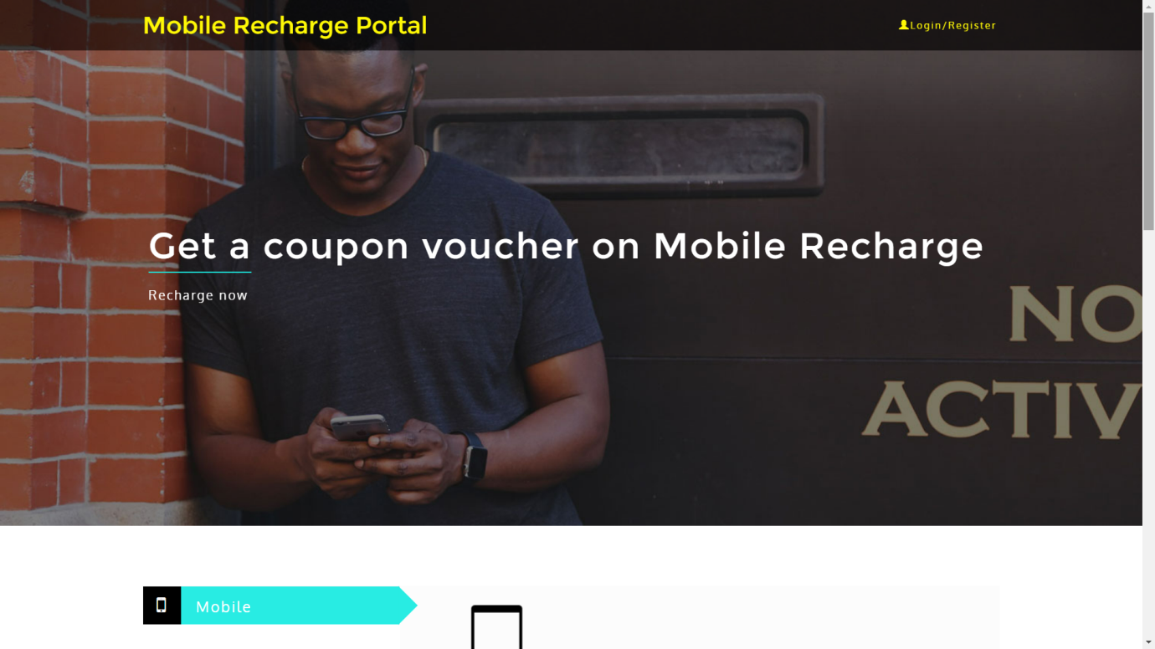

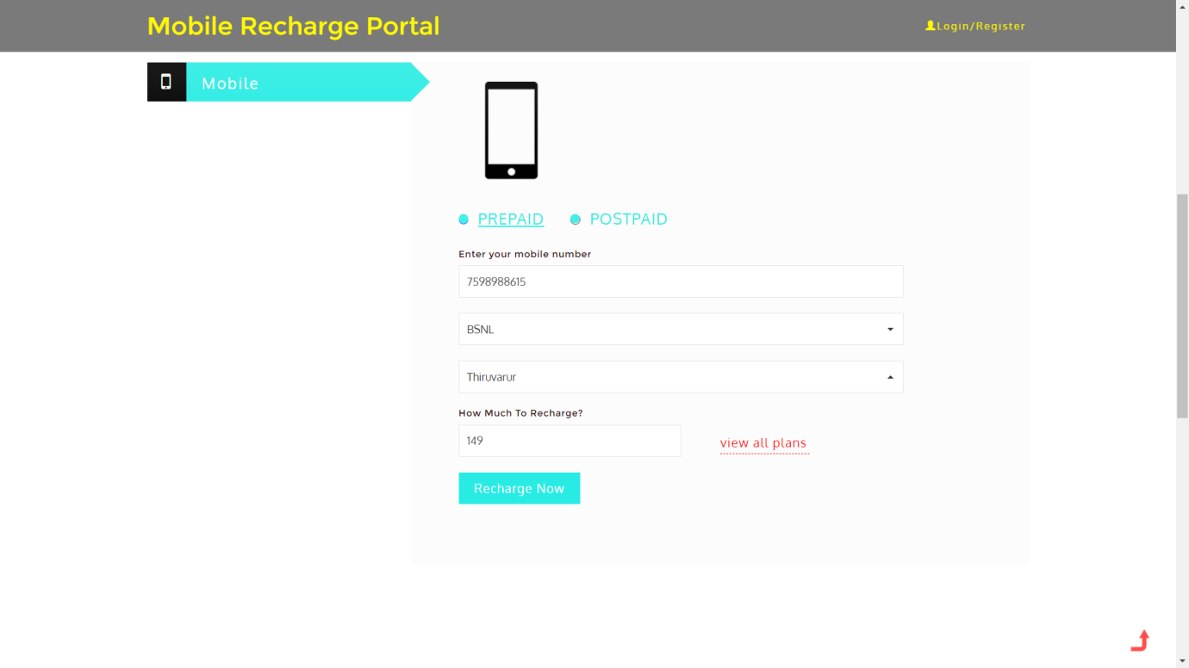

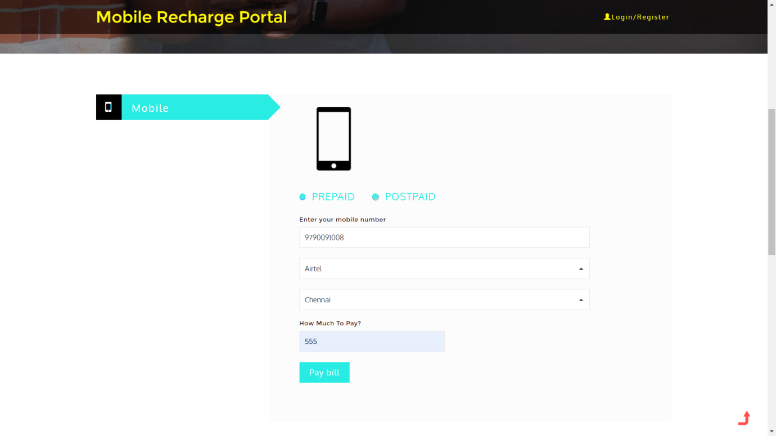

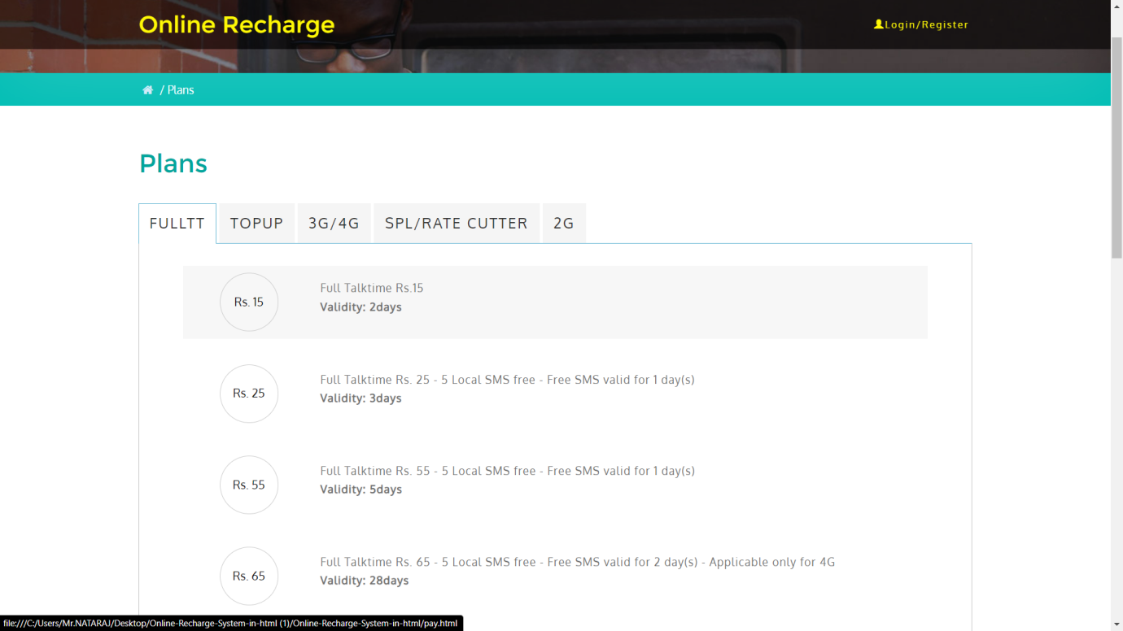

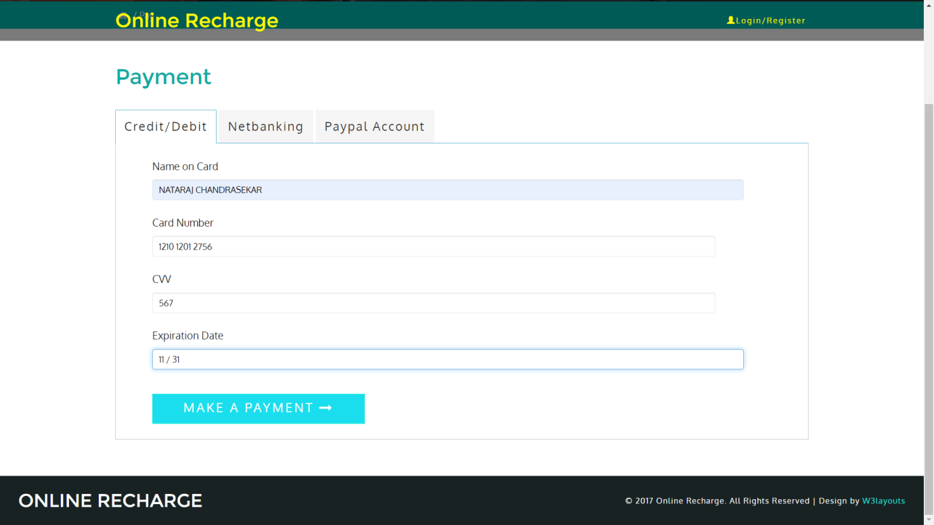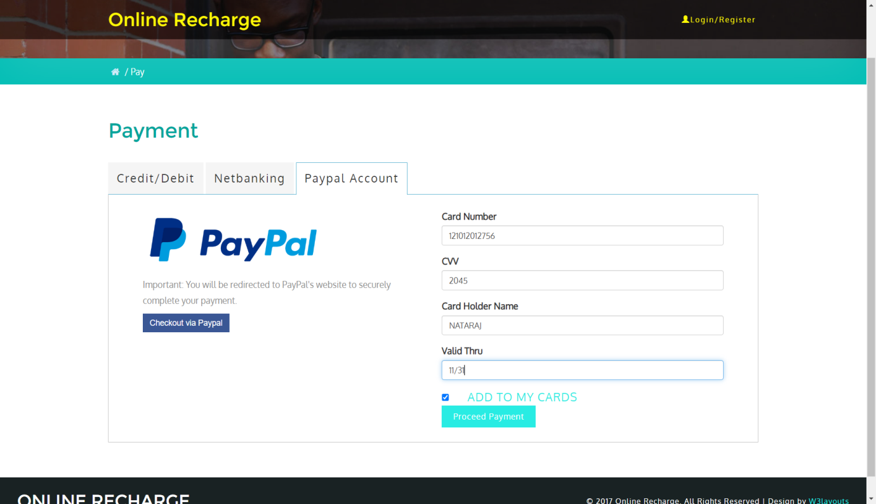

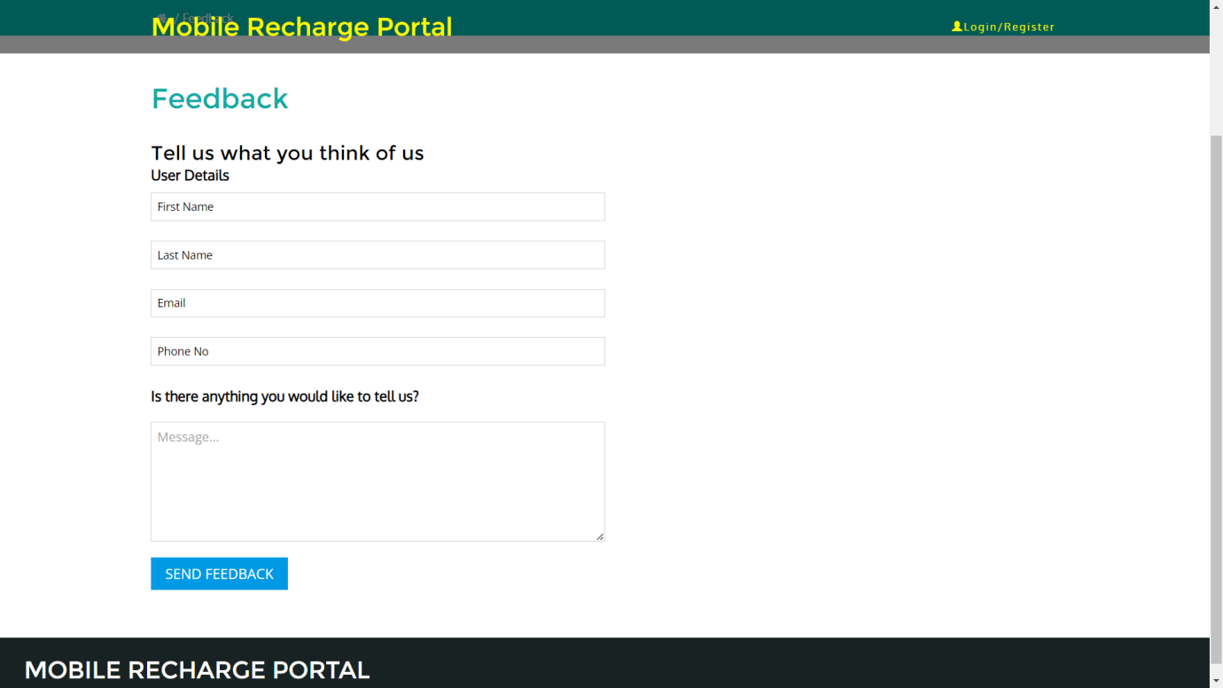

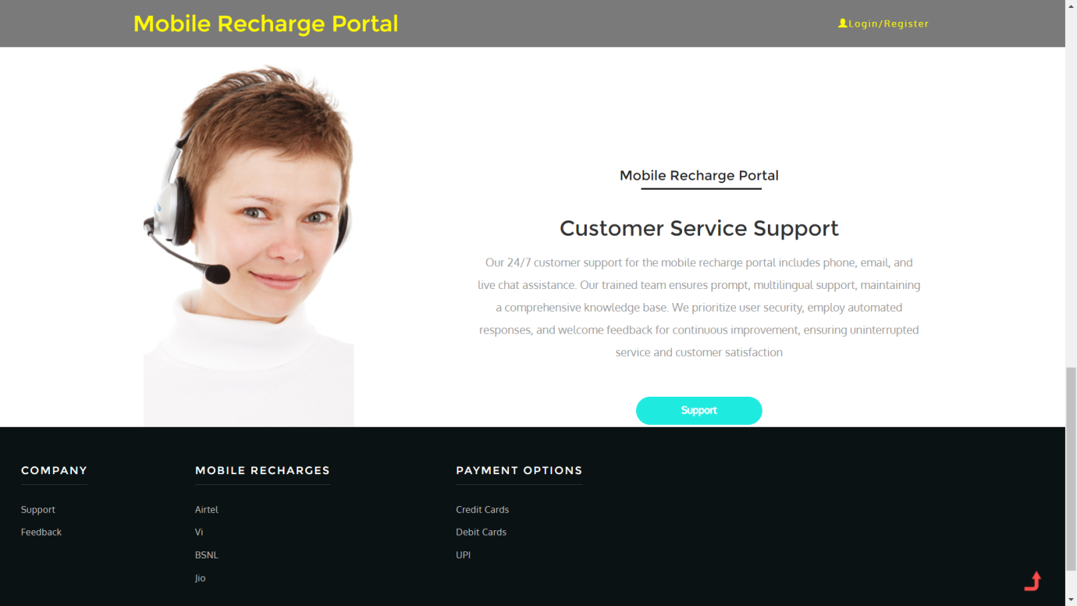

**Implementation of Test case for Mobile Recharge Portal System :**

Test case for the mobile recharge portal:

Test Case ID: TC-MRP 1

Test Engineer Name : NATARAJ C

Date: 30/11/2023

Purpose: To verify the functionality of the mobile recharge portal by testing a successful recharge transaction.

Preconditions:

1. The user is registered and logged into the mobile recharge portal.

2. Sufficient funds are available in the user's account.

3. The mobile number for recharge is valid and exists in the supported mobile operator list.

Steps:

1. Navigate to the "Recharge" section of the portal.

2. Enter a valid mobile number.

3. Select the mobile operator (e.g.,Jio ,Airtel etc).

4. Enter a recharge amount (e.g., 155 rs).

5. Choose a payment method (e.g., Credit Card).

6. Click on the "Recharge Now" button.

Input:

- Mobile Number: 1234567890

- Operator: jio ,Vi ..

- Recharge Amount: 145 rs

- Payment Method: Credit Card

Expected Output:

1. The system should display a confirmation message indicating a successful recharge.

2. The user's account balance should be updated accordingly.

3. An email and/or SMS notification should be sent to the user with details of the recharge transaction.

Pass/Fail Status:

Pass: If the confirmation message is displayed, the account balance is updated, and the notification is received.

Fail: If any step fails, such as not receiving a confirmation message or if the account balance is not updated.

Comments :

test cases for different scenarios, such as failed recharge attempts, testing different mobile operators, and various payment methods. Adapt and expand these test cases based on your specific requirements and the features of the mobile recharge portal.

**Conclusion :**

The Mobile Recharge Portal System project has successfully reached its conclusion, delivering a secure, user-friendly platform that fulfills its objectives. Rigorous testing, including functional, security, and performance assessments, ensures the system's reliability and scalability. Detailed documentation facilitates maintenance, and effective communication within the project team and with stakeholders has been pivotal. The portal, now poised for deployment, is the result of collaborative efforts and continuous improvement. Commitment to user feedback and adaptability ensures the system's relevance and excellence in the dynamic realm of mobile services. The project team expresses gratitude for stakeholder support throughout this successful endeavor.

**References :**

[https://www.coursehero.com](https://www.coursehero.com/)  [https://sites.gsu.edu](https://sites.gsu.edu/)   [https://www.slideshare.net](https://www.slideshare.net/)  [https://www.researchgate.net](https://www.researchgate.net/)  [https://www.academia.edu](https://www.academia.edu/)

<https://codebun.com>

